Evelin bought 4 packages of paper towels and 3 packages of Clorox wipes. Each package of paper towels contained 6 rolls, and each package of wipes contained 3 tubs.
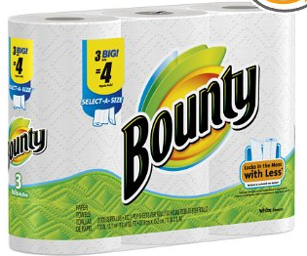  A.  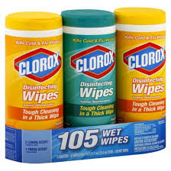 | B.  C3  C3  C3  P6  P6  P6  P6
+

